**Application Fostering Social Connections for Elderly Well-Being**

**A Software Design Specification Template**

**Prepared by ALEYNA YILMAZ 21000166**

**DOĞUKAN GÜLER 17000252**

**HASAN ODUNCUOĞLU 17330170**

**Eastern Mediterranean University**

**30/04/2024**

by Brad Appleton <brad@bradapp.net>

[http://www.bradapp.net](http://www.bradapp.net/)

Adapted for LAFS by Elliott McCrory,

Copyright © 1994-1997 by Bradford D. Appleton

*Permission is hereby granted to make and distribute verbatim copies of this document provided the copyright notice and this permission notice are preserved on all copies*.

Table of Contents

1. Introduction 1

1.1. Document Outline 2

1.2. Document Description 4

1.2.1. Introduction 4

1.2.2. System Overview 5

2. Design Considerations 5

2.1. Assumptions and Dependencies 5

2.2. General Constraints 5

2.3. Goals and Guidelines 6

2.4. Development Methods 6

3. Architectural Strategies 6

4. System Architecture 7

4.1. Subsystem Architecture 8

5. Policies and Tactics 8

6. Detailed System Design 9

6.1. Classification 9

6.2. Definition 9

6.3. Responsibilities 10

6.4. Constraints 10

6.5. Composition 10

6.6. Uses/Interactions 10

6.7. Resources 10

6.8. Processing 10

6.9. Interface/Exports 11

6.10. Detailed Subsystem Design 11

7. Glossary 11

8. Bibliography 11

# Introduction

This report is to explain and describe in detail the software structure and design of "Application to Promote Social Connections" geared toward improving the properly-being of the elderly. It offers distinctive information about the important components of the gadget to satisfy all of the necessities specific by the consumer.

## Document Outline

## 1.Introduction

1.1. Document Description

1.1.1. Introduction

Purpose

Scope

Target

1.1.2. System Overview

Section2

Section 3

Section 4

Section 5

Section 6

## Document Description

Here is the description of the contents (by section and subsection) of the proposed template for software design specifications:

### Introduction

Purpose: This Software Design Document (SDS) describes "Application that Promotes Social Connections". It will element the fundamental define of the undertaking and serve as the premise for the improvement system. This may even permit for a essential evaluation of the logical and purposeful factors of the layout earlier than they are related to the actual codes.

Scope: This report explains the concept of "Application that Promotes Social Connections" from one-of-a-kind perspectives (architectural layout, interface design). This is performed through the use of architectural fashions: use case diagrams, series diagrams, magnificence diagrams, context diagram, activity diagram, ER diagram, DFD, BPMN.

Target : This file is for developers running on "App to Promote Social Connections".

### System Overview

Section 2: Provides details of considerations when designing the device.

Section 3: Presents the simple techniques and choices made approximately the overall organisation of the gadget and the reasons for those alternatives.

Section 4: Shows the architectural design of the gadget. This offers an overview of the physical format of the components, the excessive-degree component and structure of the system, and their interactions with the person.

Section 5: Gives the policies and techniques that have an effect on a few elements of the machine.

Section 6: Provides a more specified design of the gadget. This describes the lower degree instructions and additives and their interactions with each other. It consists of use case diagrams, collection diagrams, statistics go with the flow diagrams, and so forth.

# Design Considerations

## Assumptions and Dependencies

**Assumptions**

* The machine could be to be had 24/7.
* Administrator is already created inside the machine.
* Roles and responsibilities are predefined.
* The gadget shall assist all users on the equal time.
* Details concerning elderly profiles shall be entered manually.
* System shall deliver warnings whilst incorrect procedures take region.
* The machine will be secured to defend private user records.
* Related Software or Hardware

The challenge could be designed the use of numerous layout tools like (Modelio, lucid chart, Figma) Implementation of the layout may be carried out the use of HTML, CSS, and Java. MySQL might be used to shop facts inside the database.

* End - User Characteristics
* Administrator: The administrator is the user that manages Modules Information, manage transactions, approve paperwork, create elderly profiles, schedule chats, and plenty of greater…
* User: might be able to use all device capabilities, provoke chats, have interaction in group sports, and access assets for nicely-being, additionally be able to play video games, benefit from health services and chat with other elderly human beings.

## General Constraints

* The machine should be capable of run on any working system and any browser.
* All customers should have net connectivity before connecting to the system.
* The device ought to offer fast response time.
* The device need to offer the fine security requirements and techniques to protect registered personal person info.

## Goals and Guidelines

Goal: The number one intention of developing this kind of device is to provide accessibility to aged people international, fostering social connections and properly-being. We aim to reduce social isolation and decorate fine of lifestyles by means of presenting a platform that helps significant interactions and get admission to to assets tailored to their needs. Despite present solutions within the market, we aspire to innovate and offer specific functions that address the unique demanding situations faced by means of elderly people.

Guidelines

* The KISS (Keep It Simple Stupid) approach might be used when designing the system to make sure ease of use for aged users.
* The machine might be designed in a way that feels intuitive and familiar to elderly customers, selling adoption and engagement.
* The machine will prioritize fast response time to beautify consumer experience and engagement.

## Development Methods

The method which will be used within the development of the system is "Agile" that's an iterative and incremental improvement technique. In iterative improvement approach, the product is advanced little by little, that is, the system is damaged into smaller chunks. In incremental development technique, the gadget is designed, applied, and tested incrementally.

Reasons for the use of the iterative and incremental development techniques collectively:

* It reduces the chance of delay.
* It is less complicated to test and debug at some stage in a smaller new release.
* Repetitions of the exclusive phases can be built to ensure that the gadget sincerely meets the expectations of the client.
* Defects may be determined on the early levels.

# Architectural Strategies

**Modifying for Betterment:** We must enhance the current system. We can use past experiences and methods to make the project last and easier to manage.

**Website Basics:** We need a single place for all web tools. This spot should be online. Only admins can change and use it.

**Linking to Data:** We should link the database to the same web network. It should back real-time shifts. Keep up the database on the main computer.

**Outside Data:** We won't use outside databases. All data work will stay with the local one.

**Trust and Working Together:** The net must be strong. It should fix any issues with the web tools. Users need safe ways to see and work with data.

# System Architecture

System Architecture Diagram

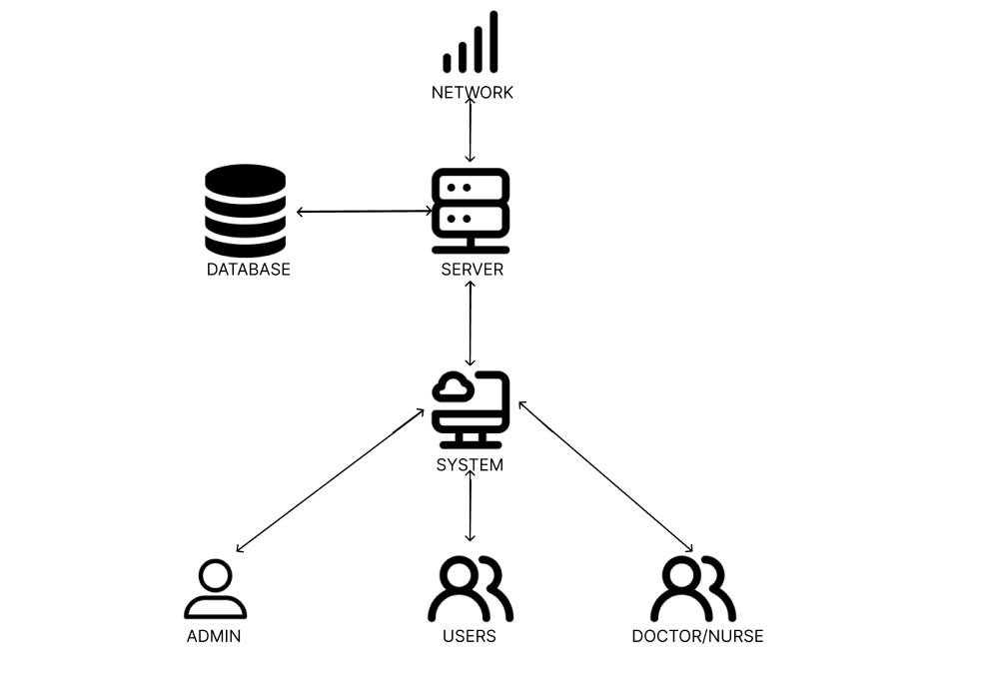Figure 1: System Architecture Diagram

## Subsystem Architecture

Context Diagrams

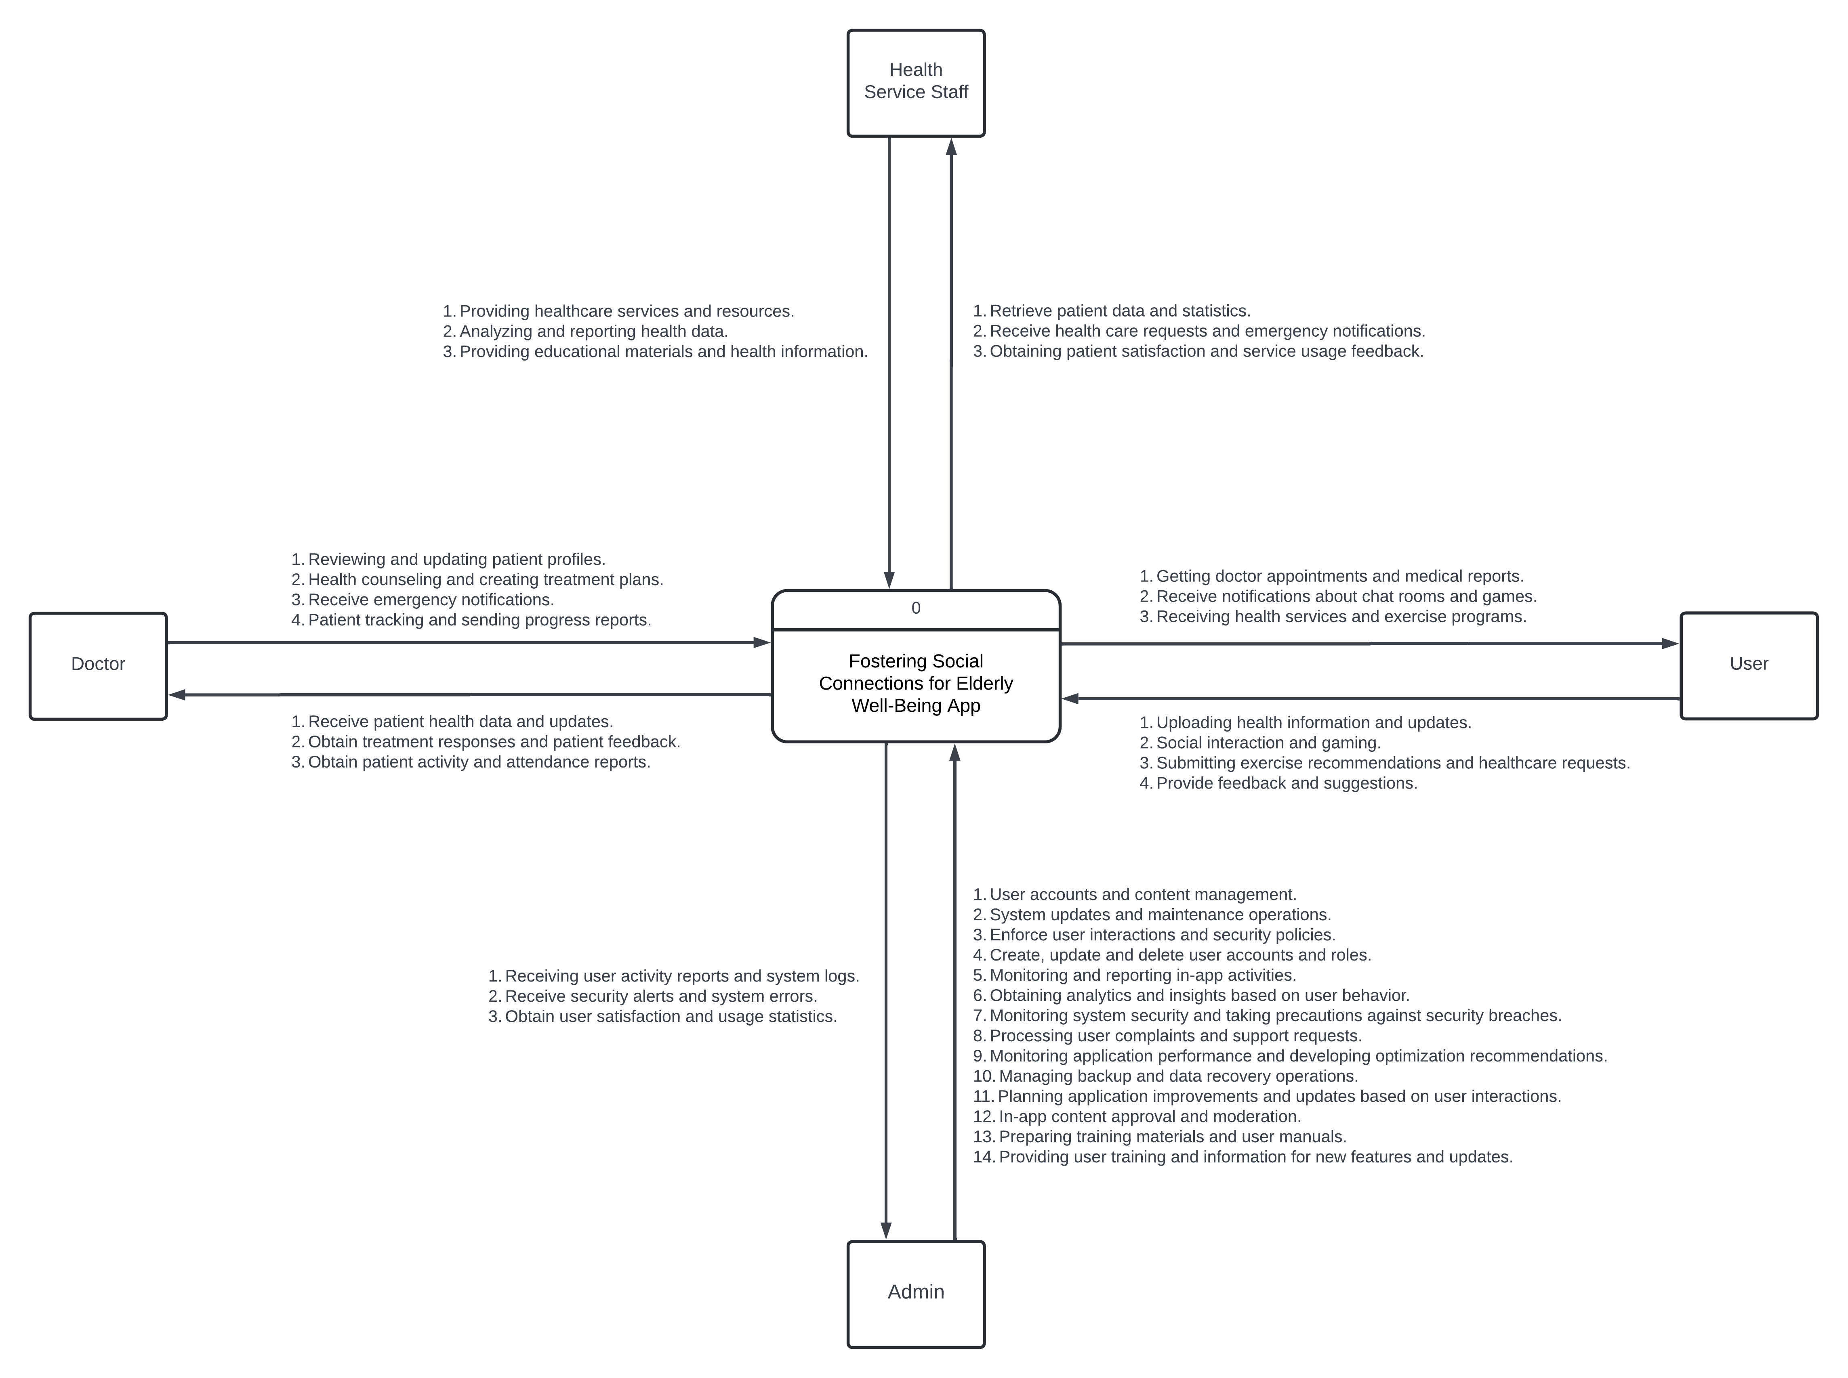Figure 2: Context Diagram

# Policies and Tactics

The plan will use Python, HTML and CSS. It will work on Windows 11. All needs will be detailed in the System Requirements Document during development. The document will cover all tech needs and project functions.

We'll design the system by considering use cases. These will ensure functions work correctly and are well-defined. Use cases will help make it user-friendly and meet needs.

All features and needs will go through testing. We'll report and fix any issues found. This will boost system trust and ensure a good user experience.

Users need internet access. They may need to log in. It will work on any internet-capable device. This lets users access it from any device.

# Detailed System Design

## Classification

Class Diagram

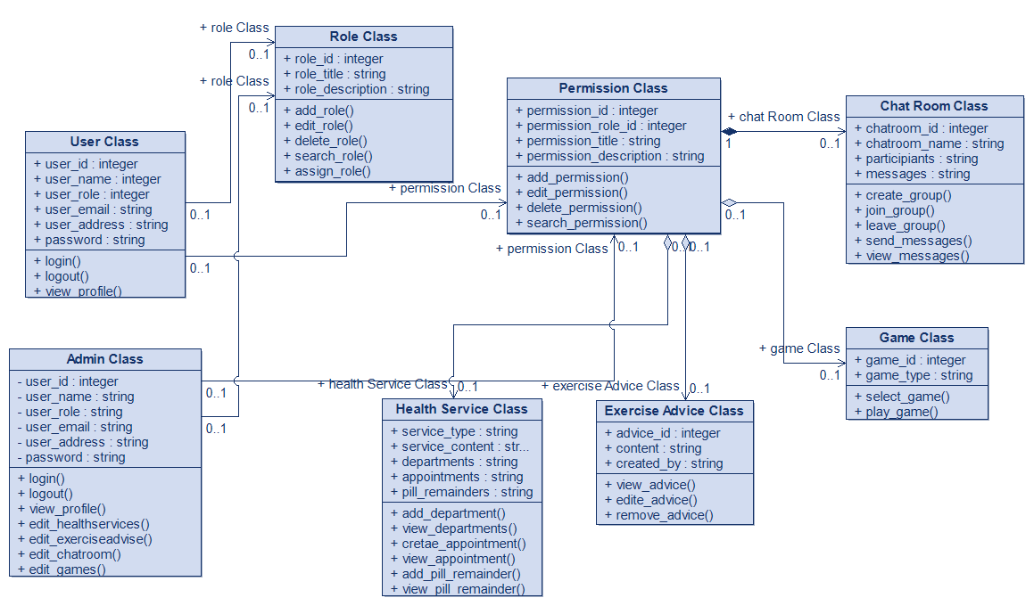Figure 3: Class Diagram

## Definition

The component's particular objective and semantic significance are described above.These diagrams represent each requirement in order to make it clear to the developer. The main level is broken up into sub levels for additional functionalities.

## Responsibilities

The main responsibilities and/or behaviors of the modules are:  
  
Health Services Module: This system section is accessible to both users and administrator. It provides users with the opportunity to provide healthcare services to a specific senior citizen. Users can benefit from health services. Users can check the status of health services. Health staff treatment services can be provided by doctors.  
  
User Module: Both administrators and users can access this module. Users can benefit from Notifications, health advice, exercise recommendations. The administrator performs user-related management (Create, Delete, Update).  
  
Social Interaction and Gaming Module: This module can be accessed by administrators and users. Users can provide support through social interaction options and games. They can chat with each other via chatroom. Administrator can control users' security.  
  
Notifications Module: This system section allows the administrator to manage and assign modules, view and update profile information of users and seniors. Health Staff may share health advice with users.

## Constraints

Here are some restrictions for Application Fostering Social Connections for Elderly Well-Being:

Health Services Module:

This module may also consist of health policies and strategies.

Only users with a single account can benefit from the services in this module.

User Module:

Only users with one account can register.

The machine will allow the user to log in or check out if they are no longer registered.

Restrictions: Only user with a single account can register.

Social Interaction and Game Module:

Users' participation in social interaction and video games may be subject to age regulations.

Users' interactions and in-recreation behavior can be restricted with the help of chat rules and tag guidelines.

Notifications Module:

The manager will be responsible for facilitating verbal exchanges between the user and the elderly.

Notifications can be limited or customized depending on users' privacy options.

Data Privacy and User Consent Module:

The privacy of users' personal statistics will be subject to legal regulations consisting of the GDPR.

Users must give explicit consent to how their private statistics may be processed.

User Support and Feedback Module:

Users need to be able to log app-related issues and request support.

Feedback can be evaluated for continuous improvement of the application.

Application Accessibility Module:

The app needs to be optimized for specific devices and screen sizes.

Special interface options should be offered to visually or hearing impaired customers in accordance with accessibility requirements.

## Composition

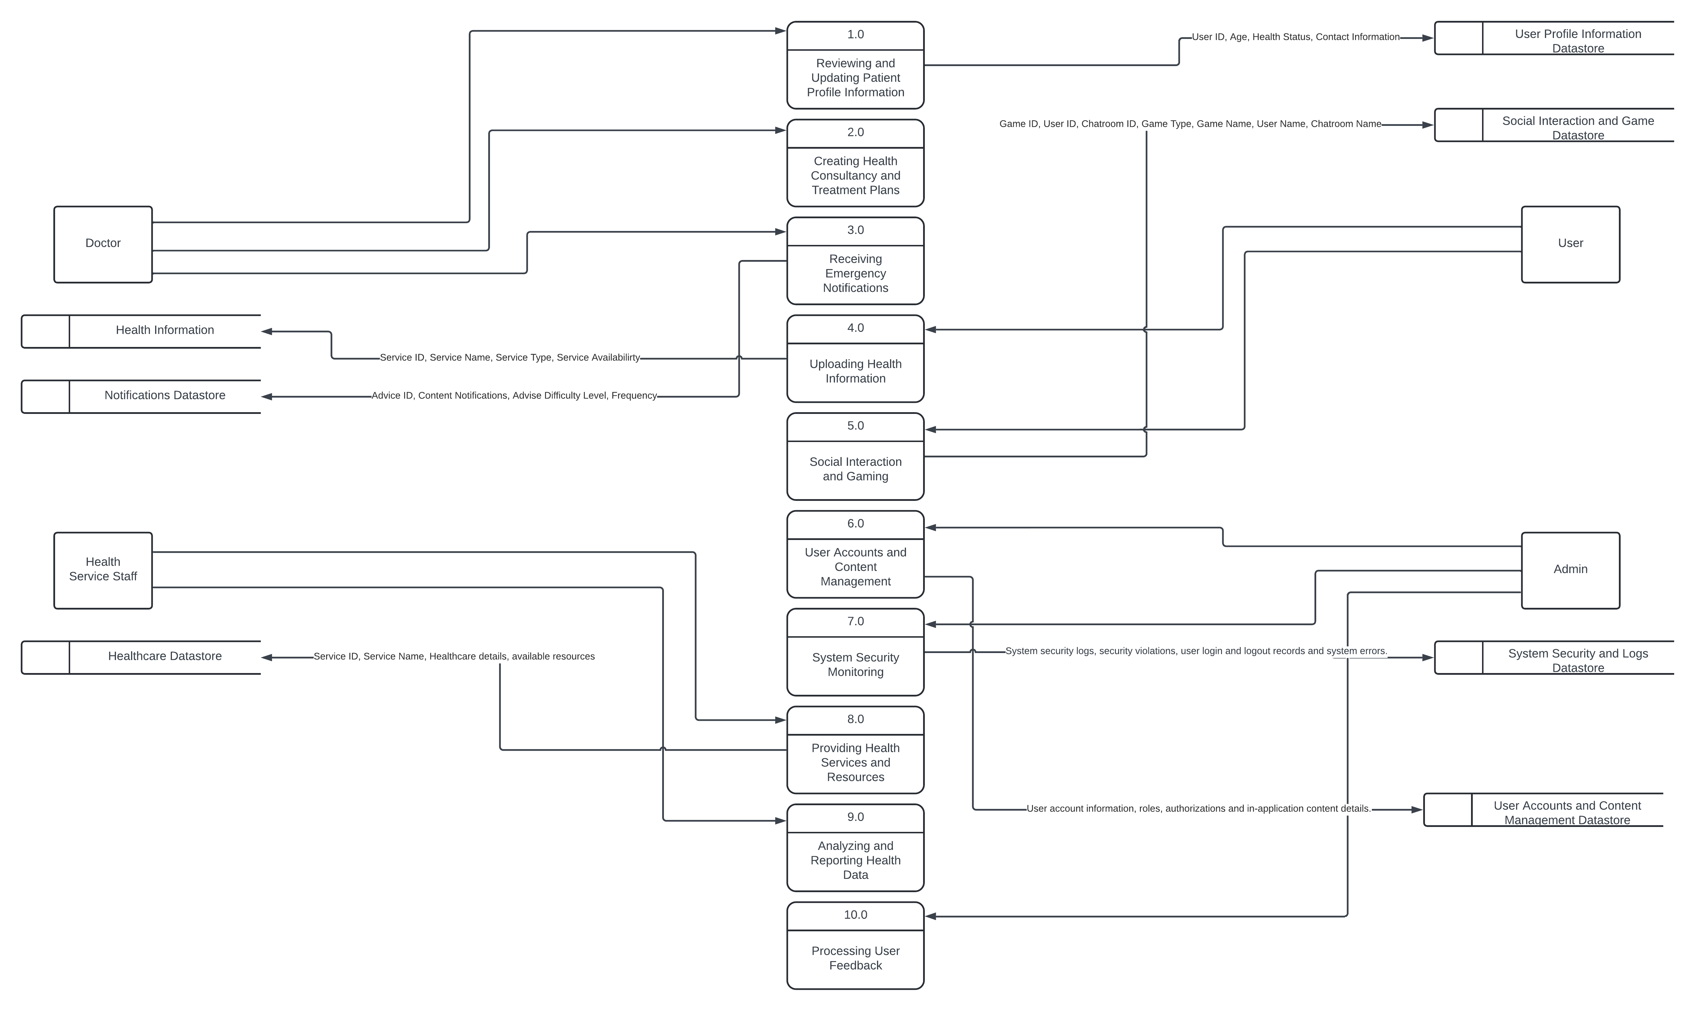Figure 4: Data Flow Level 0 Diagram

## Uses/Interactions

The interactions between the classes are defined in the class diagrams drawn and stated above in 6.1 (Figure 3).

## Resources

The main resource is a server and database. Most of the functions will be running from and managed through this resource.

## Processing

|  |  |  |  |
| --- | --- | --- | --- |
| **Function (F)/ Module (M)** | **Input** | **Output** | **Access** |
| **Login (F)** | User Credentials  (Username & Password) | System Homepage | Registered Users, Admin, Health Staff |
| **Signup (F)** | User/Staff Detailed | Login Screen | All |
| **Health Service (M)** | Select Service Name | User assigned to health services | Admin ,User, Health Staff |
| **Social Activities (M)** | Select User/Chatroom Name | Chatting amongst them | Registered Users |
| **Games (M)** | Game selection | Playing games | Registered User |
| **Modify Account (F)** | User Credentials  (Username & Password) | Account Details Page (Updated) | Registered Users,Admin |
| **Delete Account (F)** | User Credentials  (Username & Password) | Success Page, system Homepage | Registered Users,Admin |
| **Notifications (M)** | Sending notifications | Notifications Contents | Registered User |
| **View users (F)** | Module selected | List of users | Admin, Health Staff, Doctor |
| **Add/Modify users(F)** | User Information | User Profile, Updated DB | Admin |
| **Remove users(F)** | User Profile | Updated DB | Admin |
| **Contact(F)** | Selected User to contact | Successful communication | Registered User, Doctor, Health Staff |
| **Logout(F)** | Logout button clicked | Successful logout | Registered Users, Admin, Health Staff |
| **Search (F)** | Users information | Desired user is found and returned | Registered User |

## Interface/Exports

• We’ll be combining the use of HTML, CSS, Java and MySQL.

• Algorithms and experience from previous Projects would be employed in this Project and areas of improvement and modifications (to suit the current system) would be highlighted and eagerly worked upon.

• Database would be connected and maintained over similar internet network interface enabling real time modifications and updates via the host.

• External database(s) would not be employed on this project.

• Internet service dependability would handle issues of data concurrency with GUI elements.

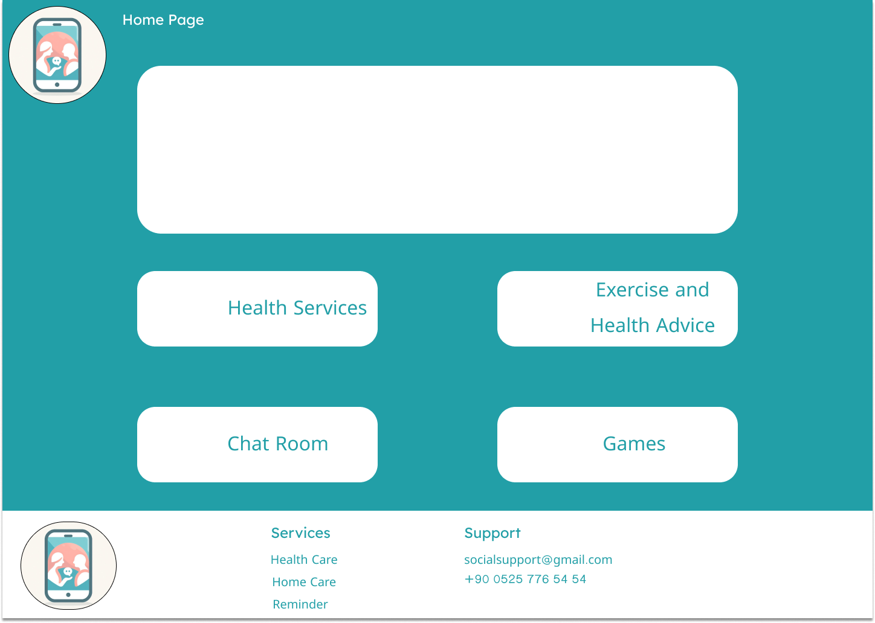Figure 5.1 UI Page 1

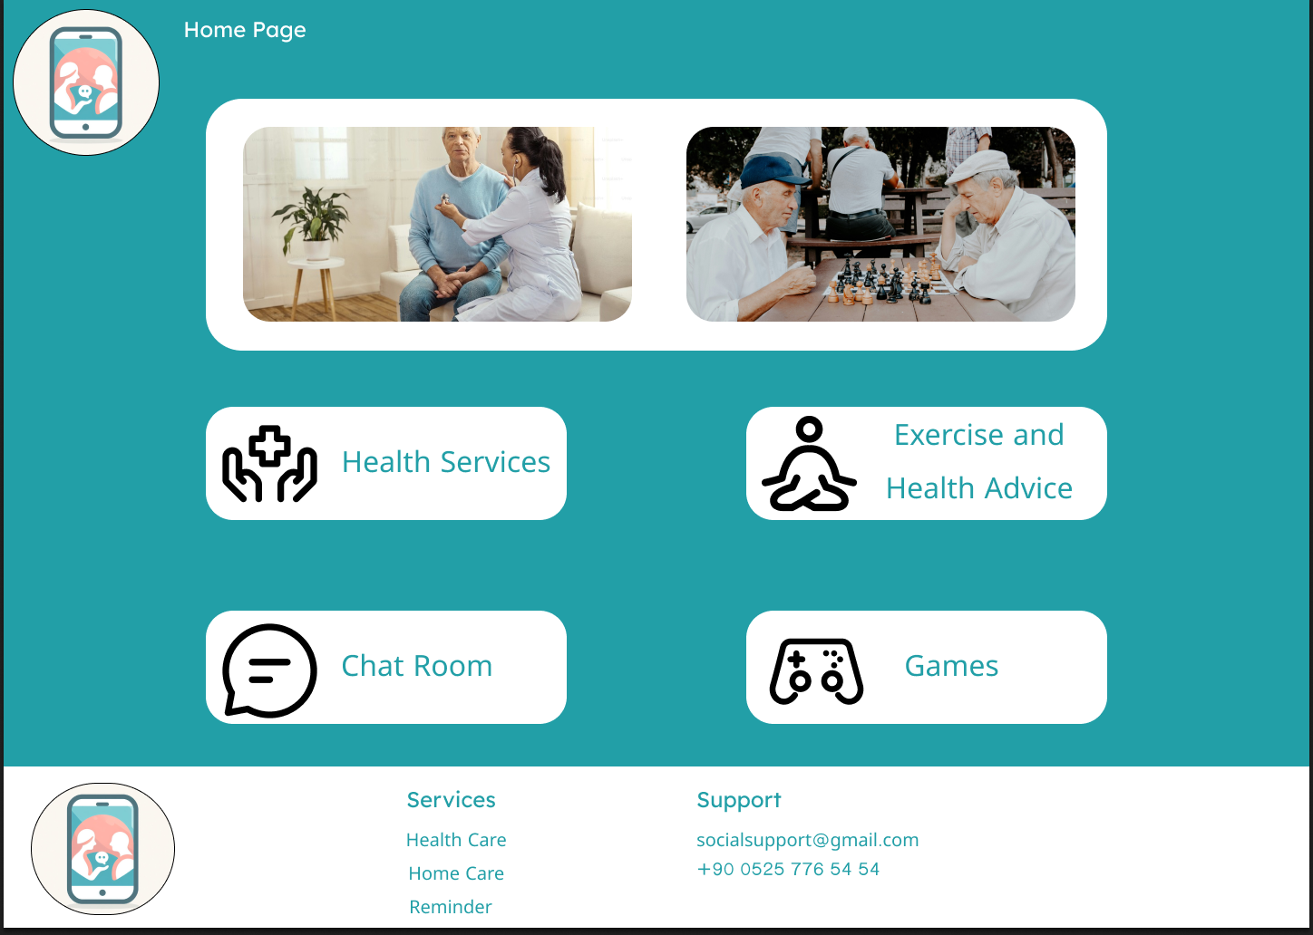Figure 5.2 UI Page 2

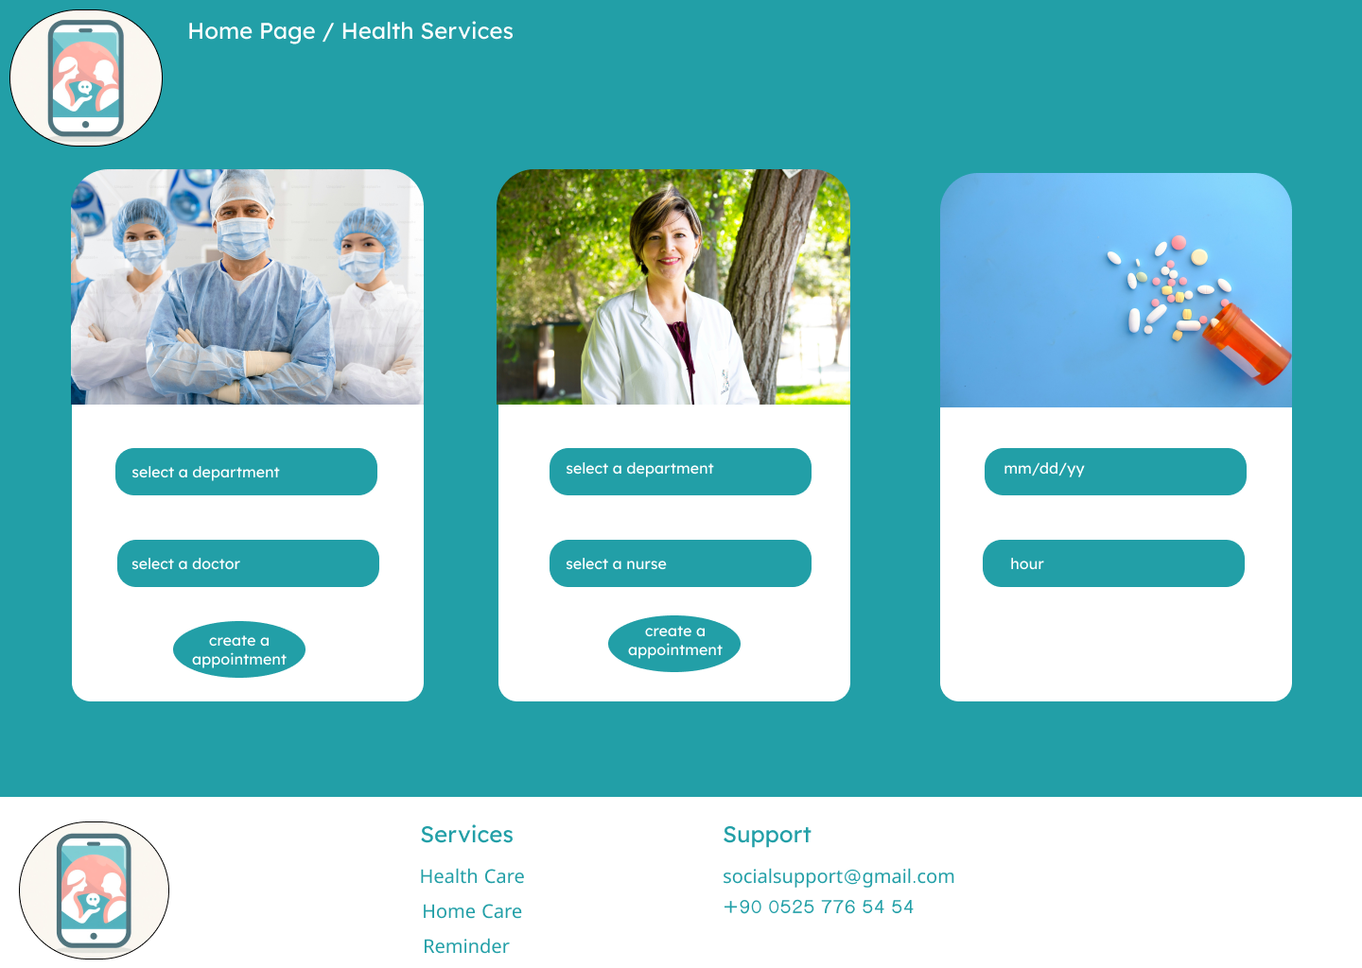Figure 5.3 UI Page 3

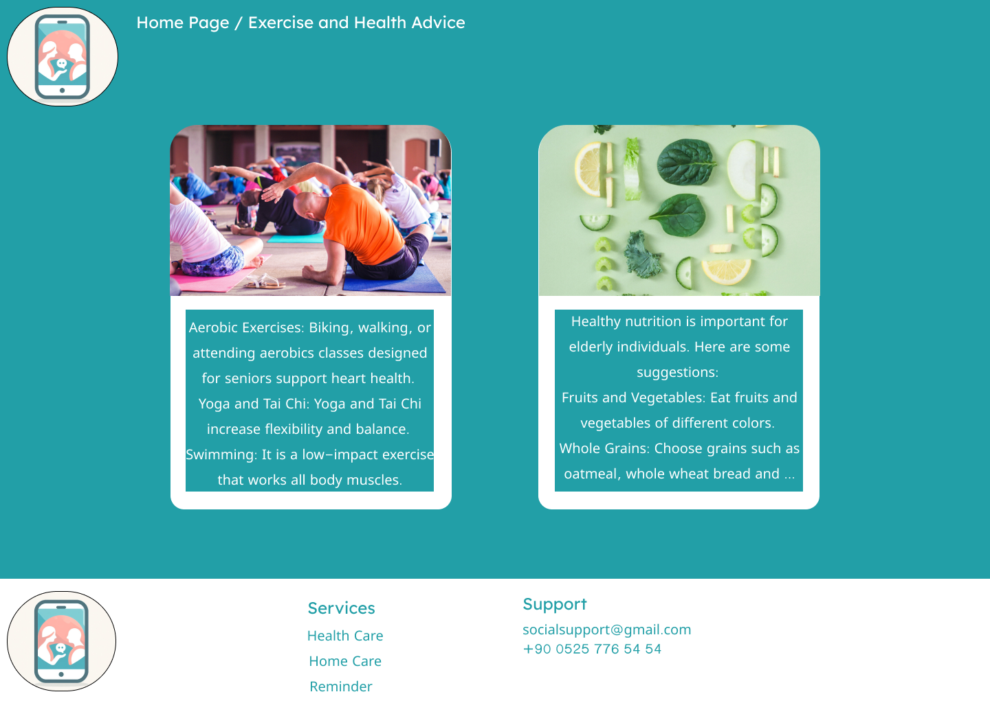Figure 5.4 UI Page 4

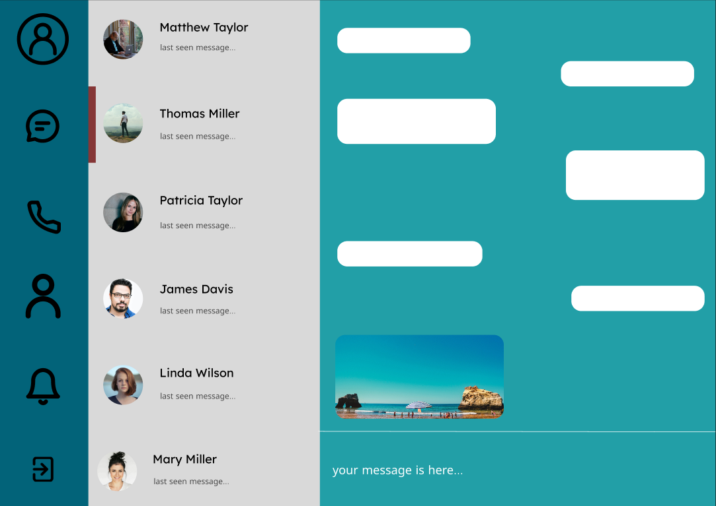Figure 5.5 UI Page 5

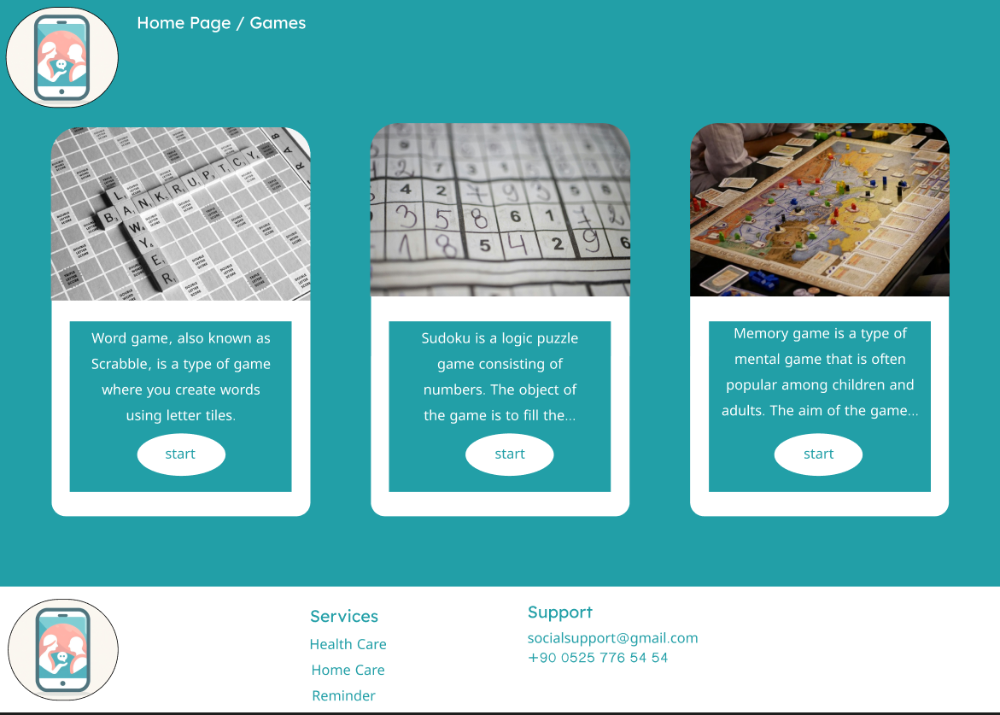Figure 5.6 UI Page 6

## Detailed Subsystem Design

Use Case Diagram

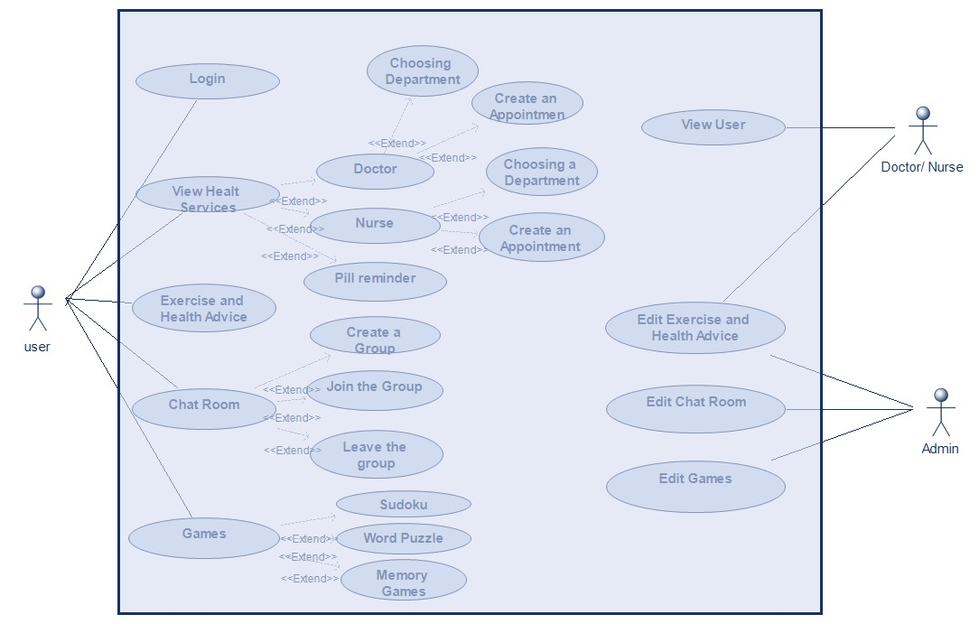

Activity Diagrams

Figure 7: Activity Diagrams Full

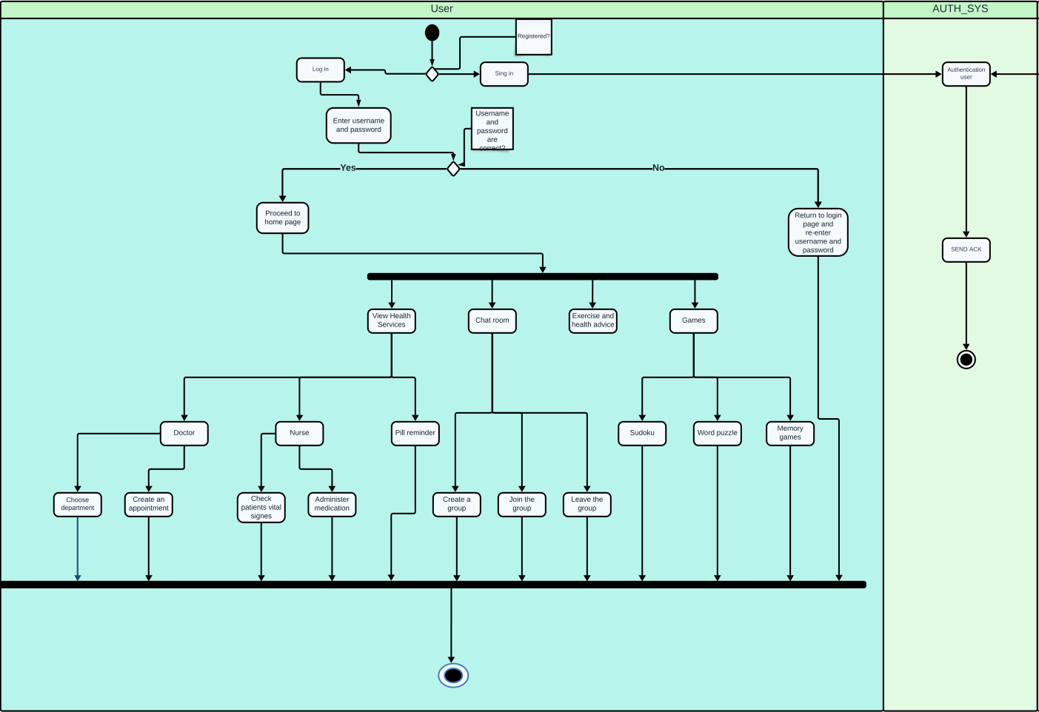

Figure 7.1: Activity Diagram User

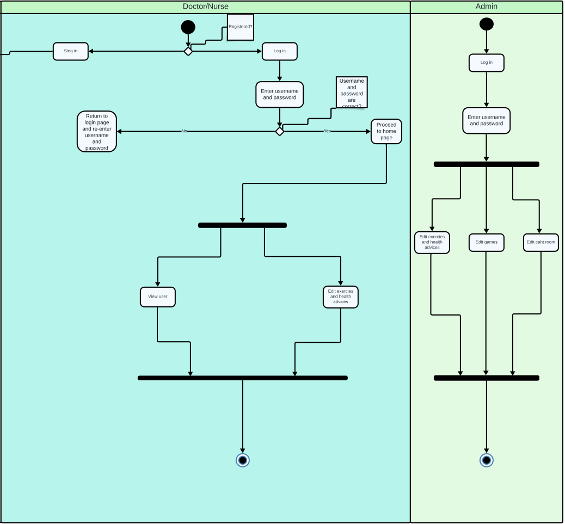Figure 7.2: Activity Diagram Doctor / Admin

Sequence Diagrams

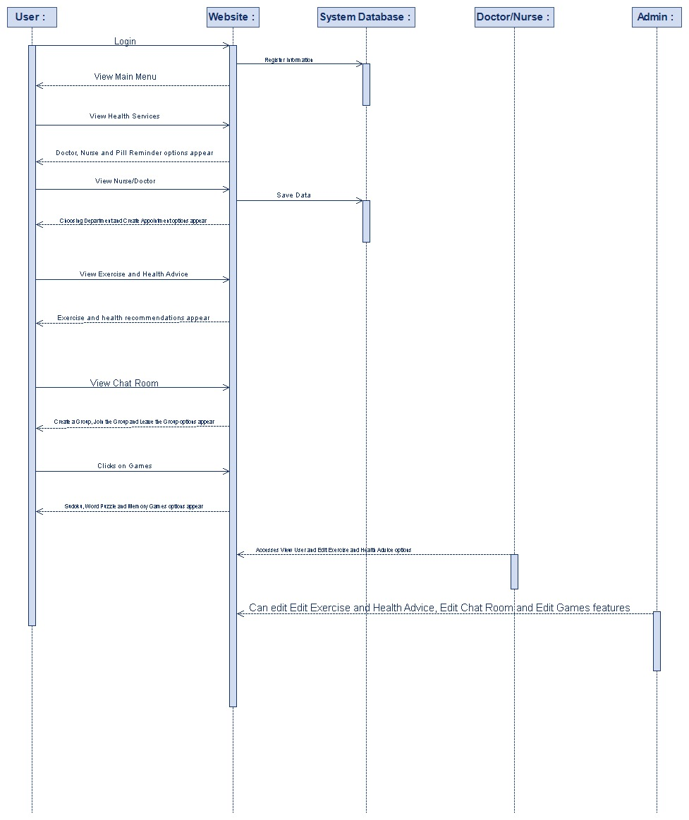Figure 8.1: Sequence Diagram

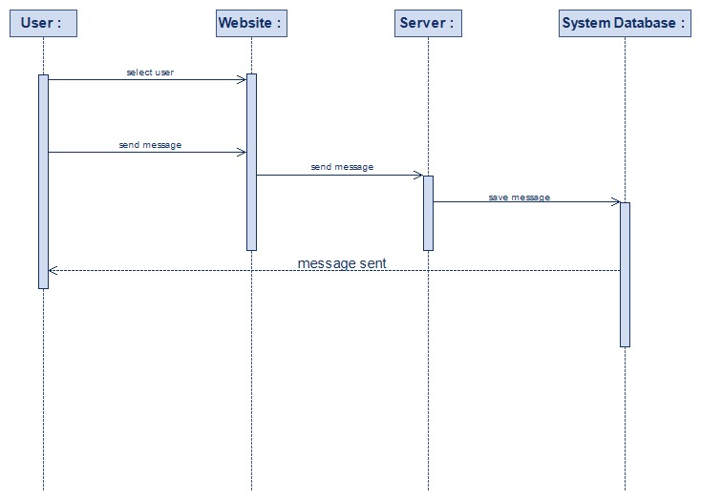Figure 8.2: Sequence Diagram

BPMN Diagram

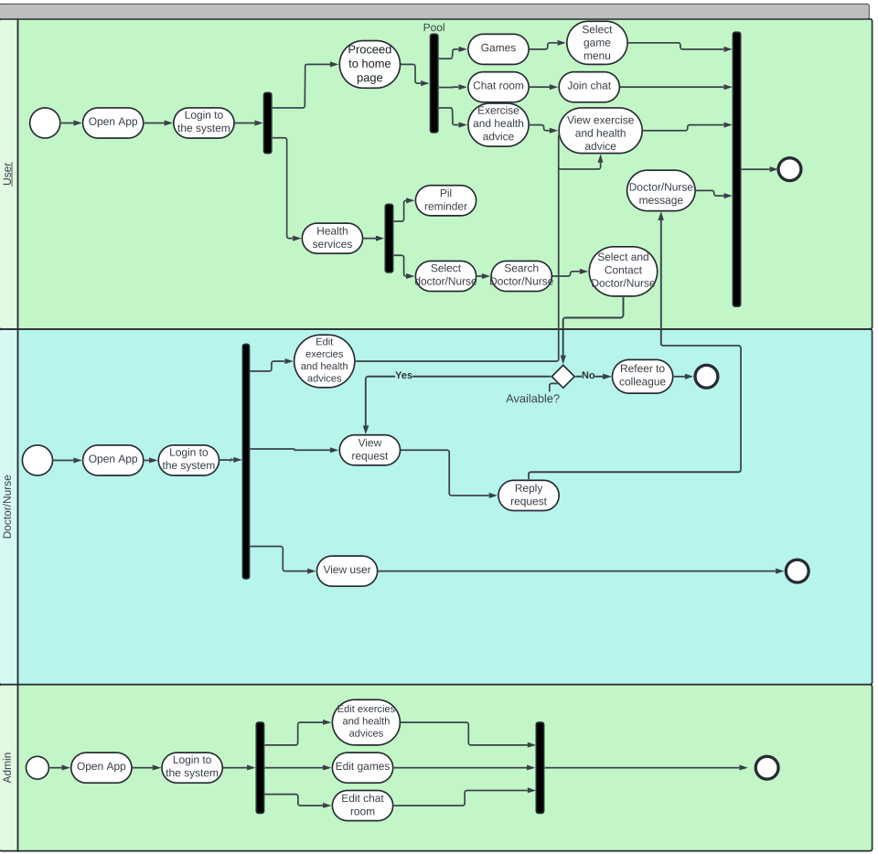Figure 9: BPMN Diagram

ER Diagrams

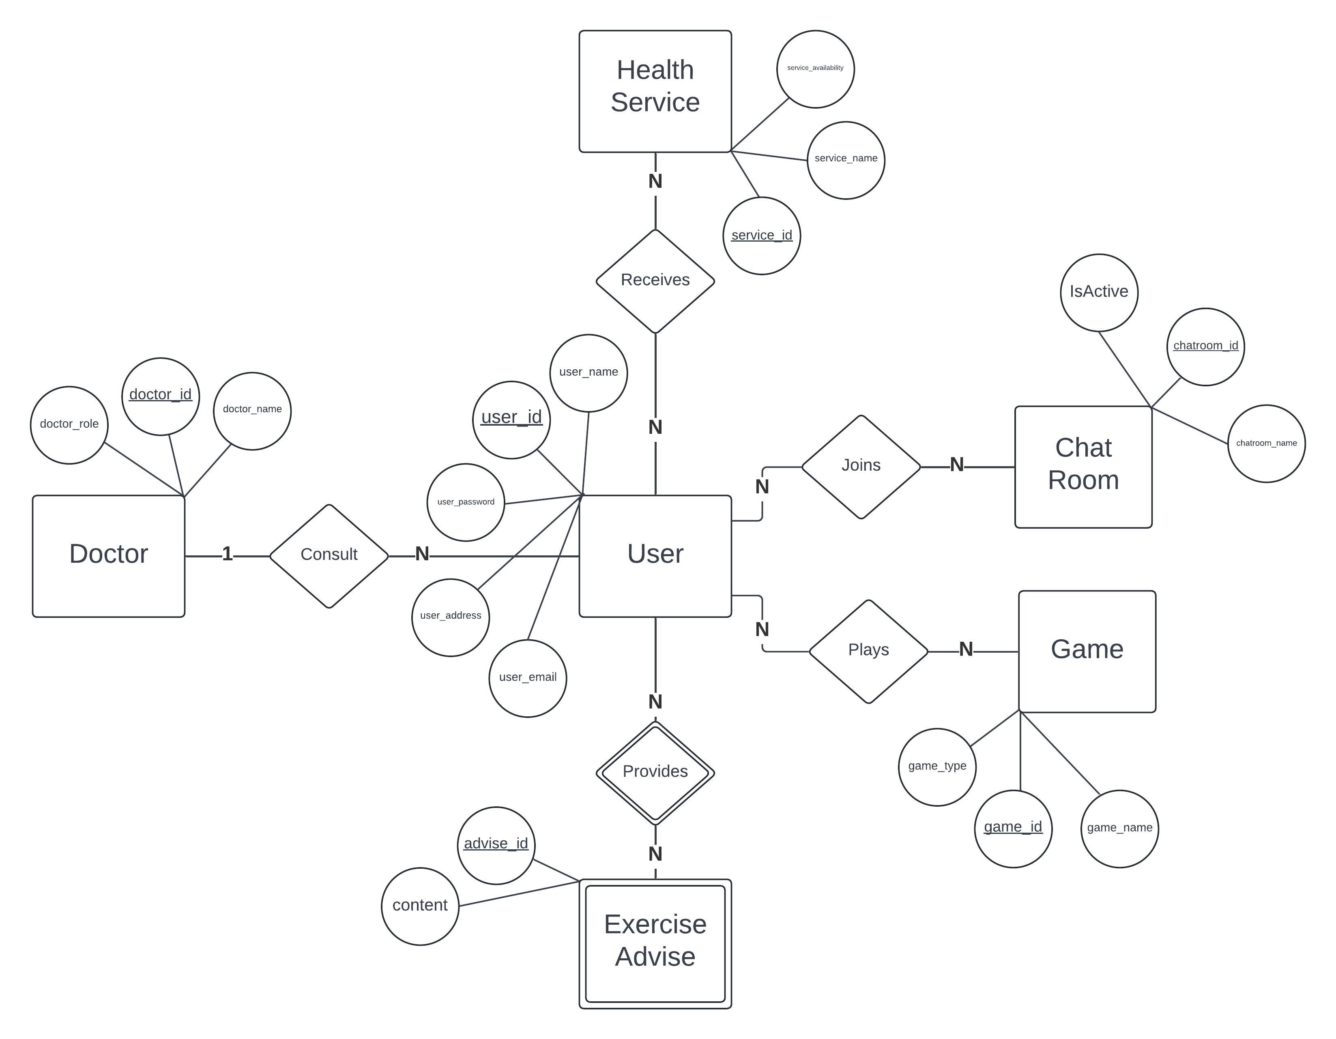Figure 10: ER Diagram

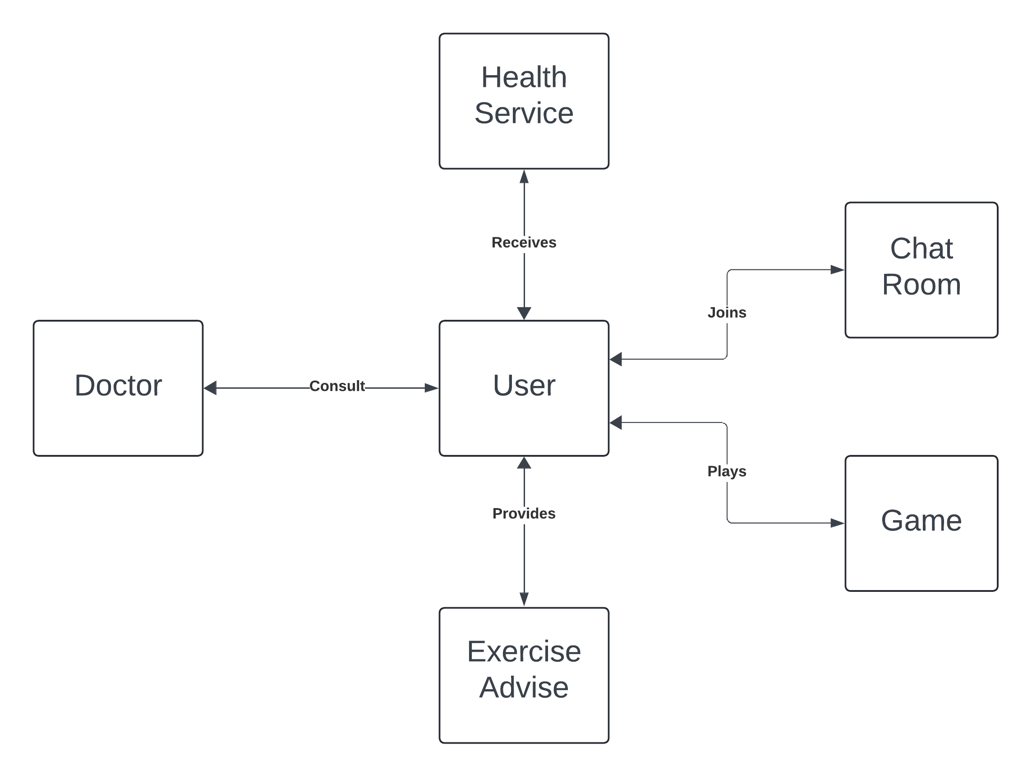Figure 10.1: Conceptual Data Model (CDM)

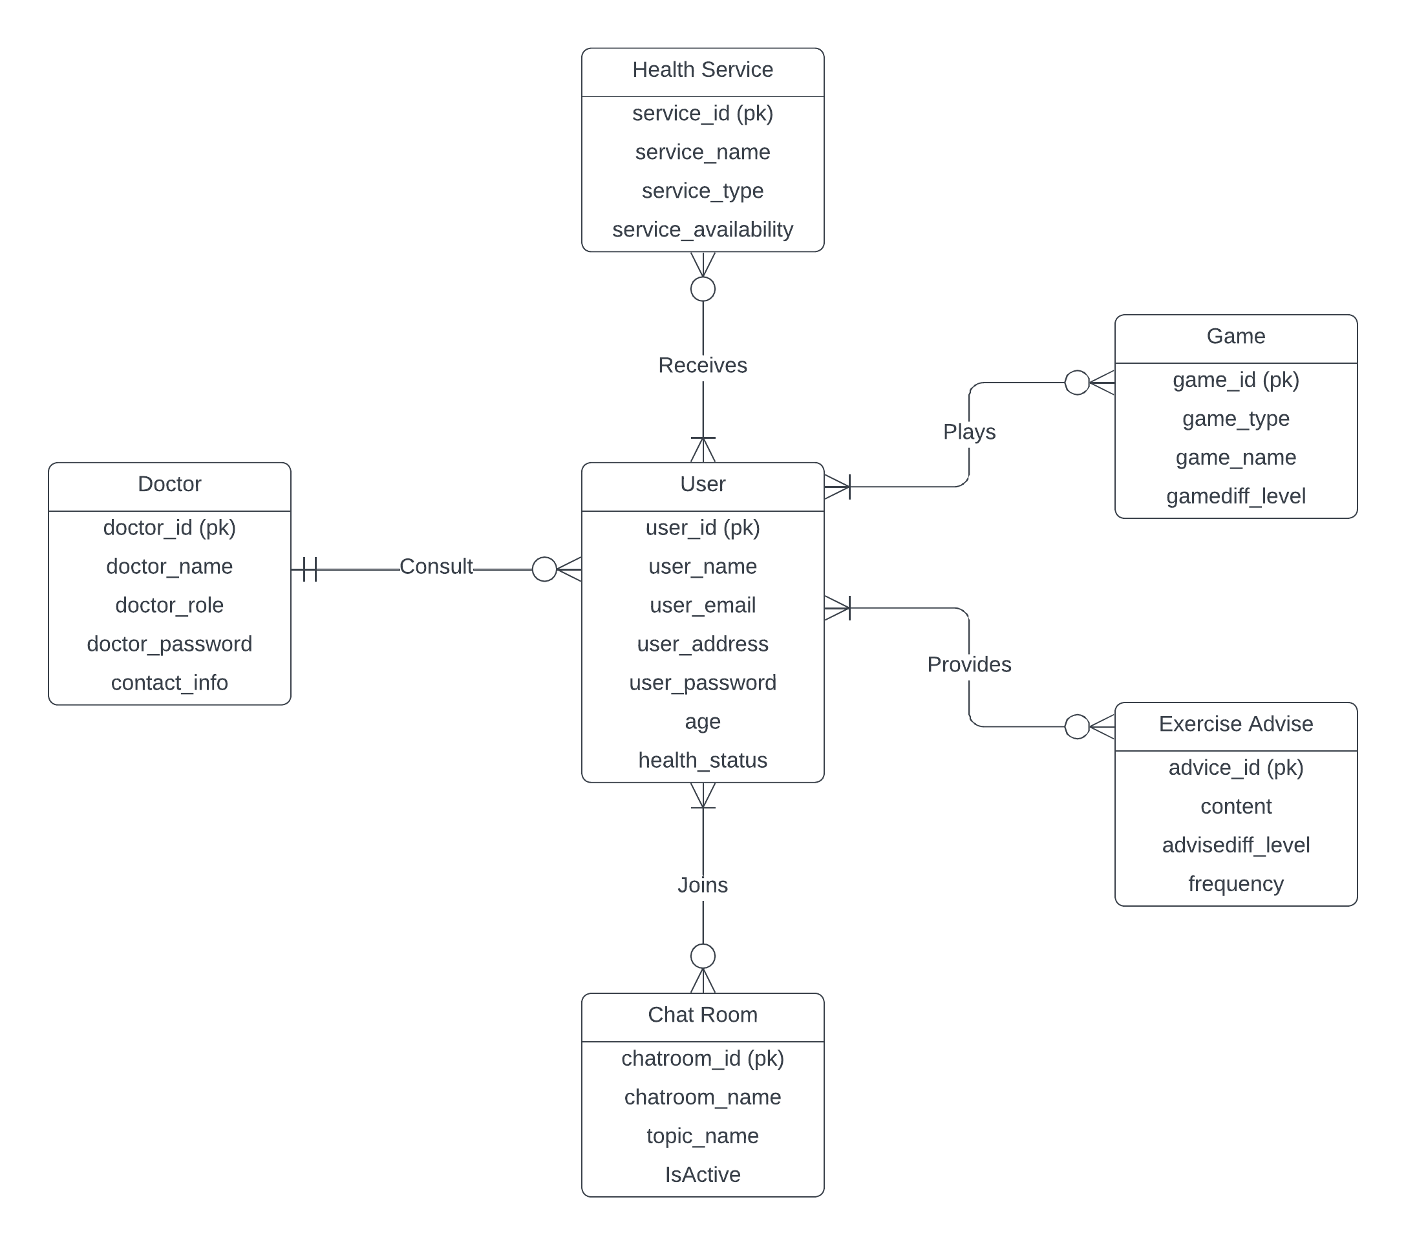Figure 10.2: Logical Data Model (LDM)

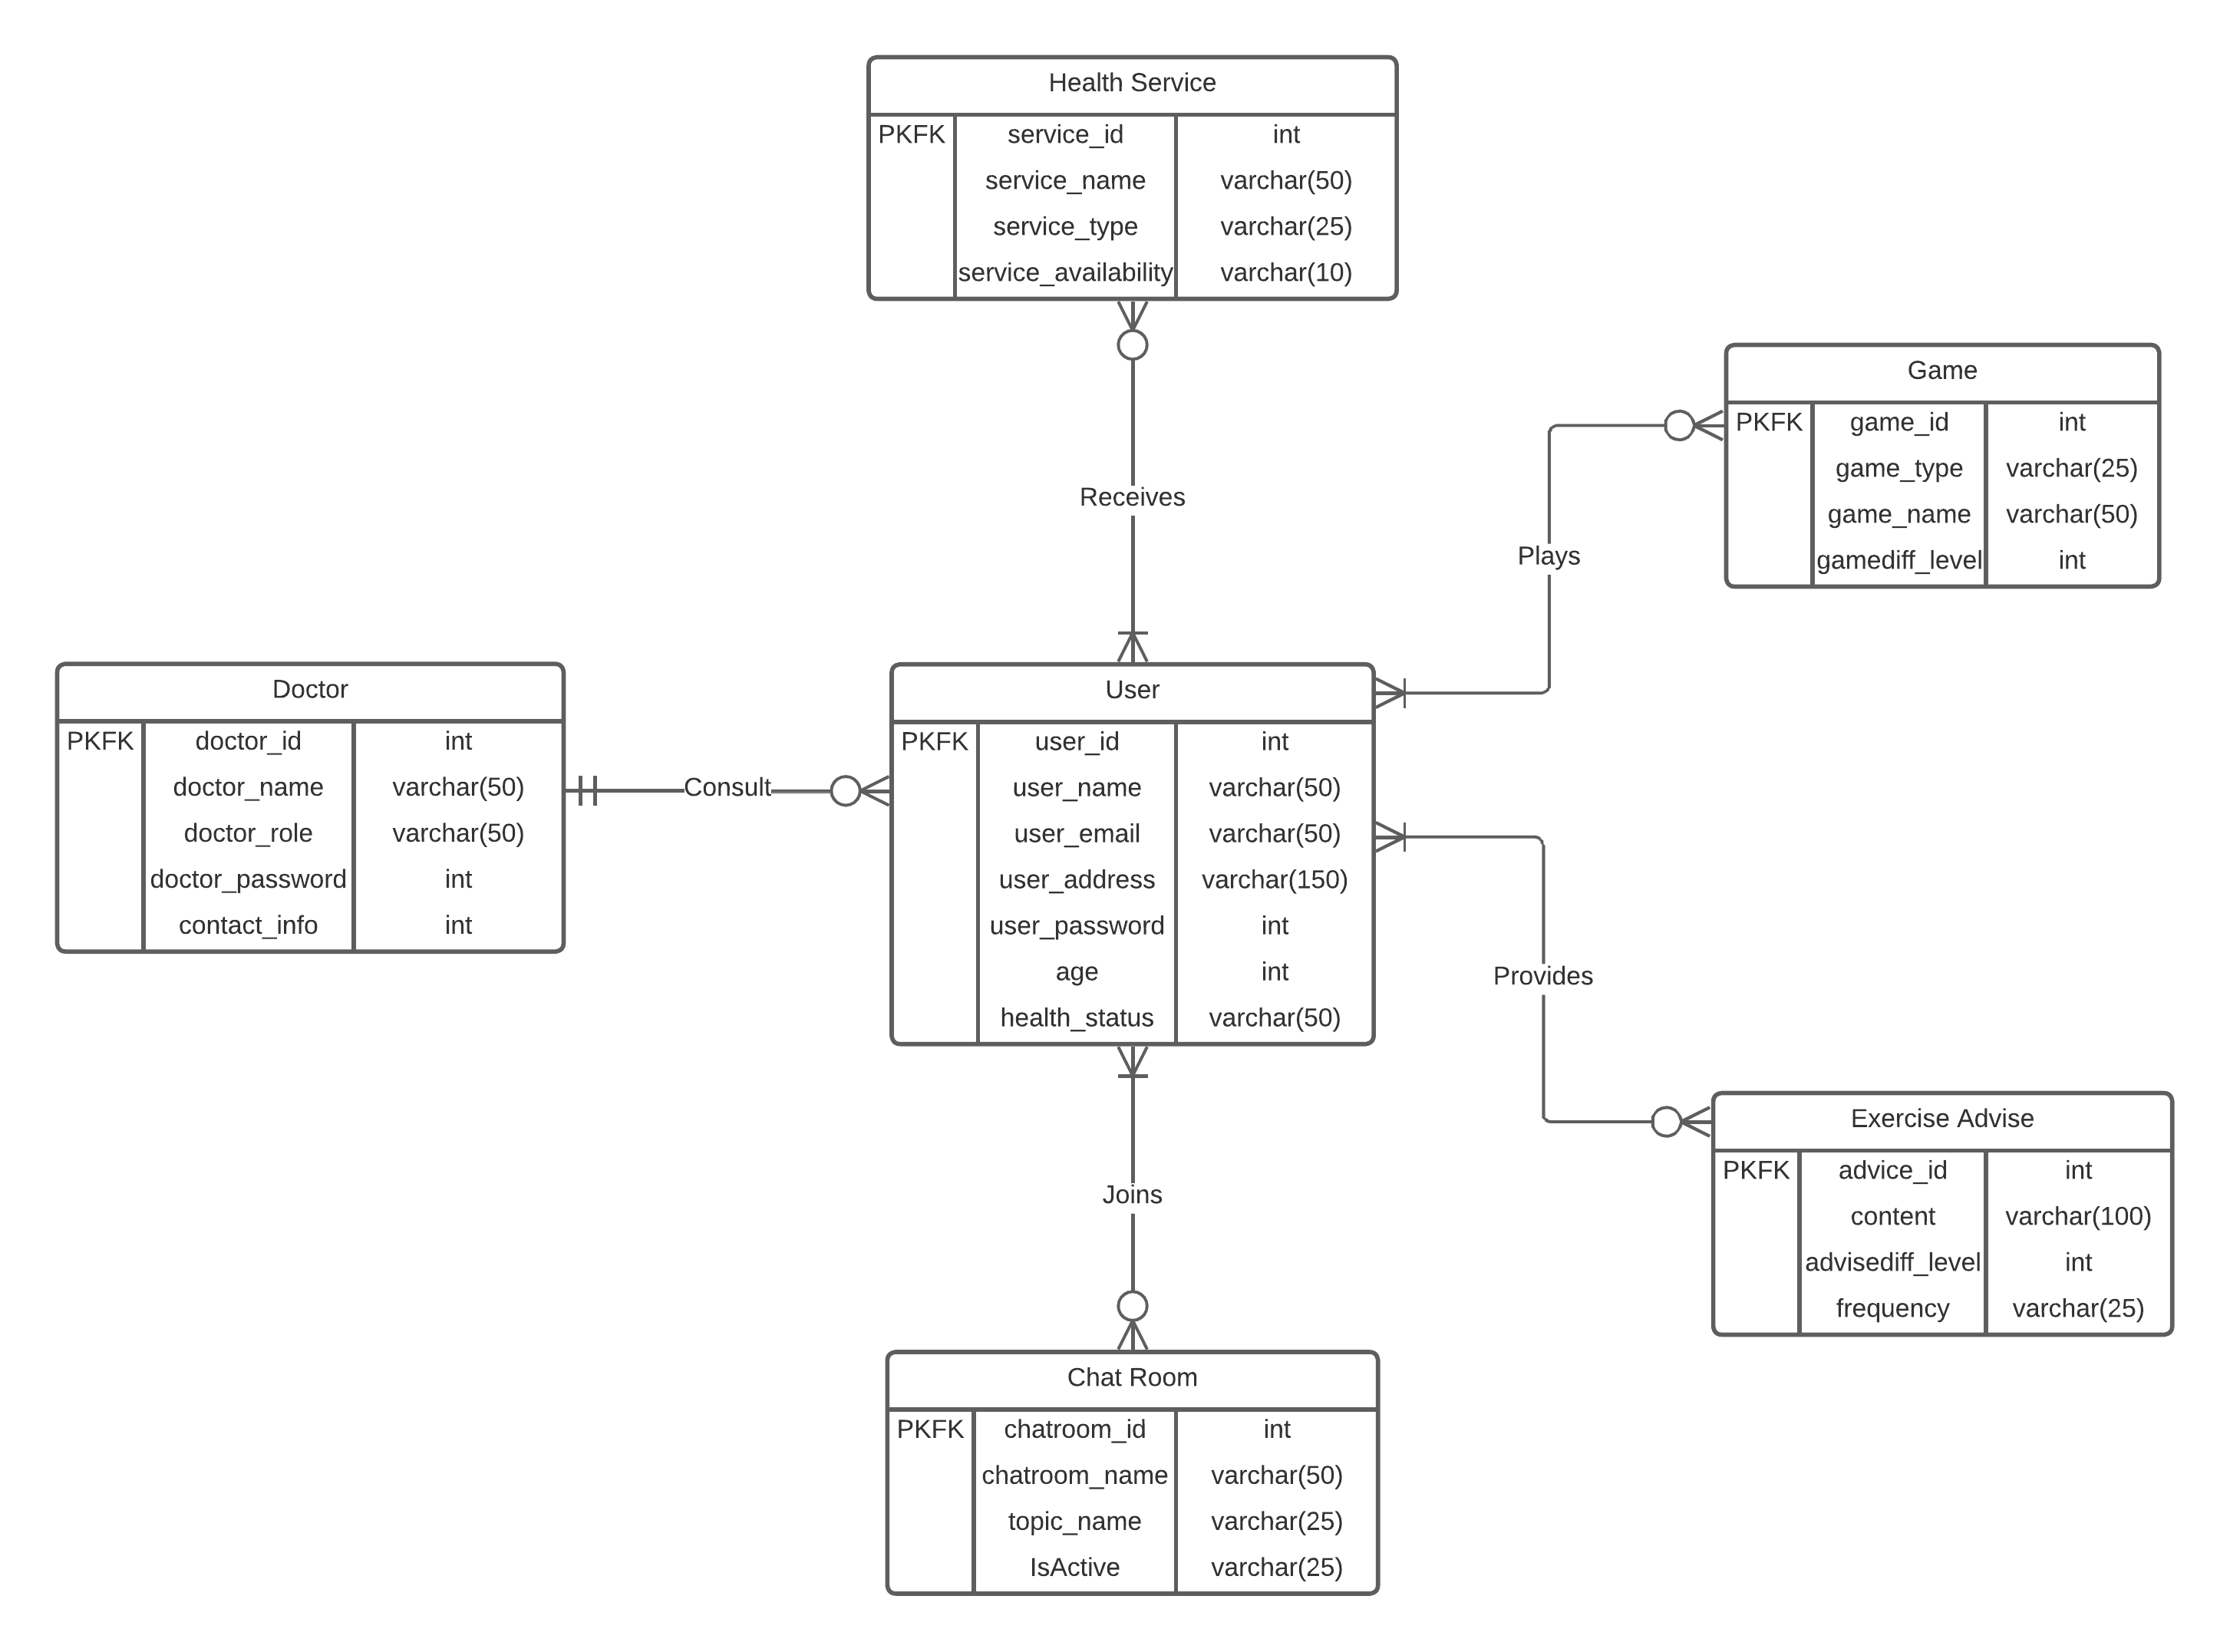Figure 10.3: Physical Data Model (PDM)

Data Flow Diagrams

Figure 11: Context Diagram

Figure 11.1: Data Flow Level 0

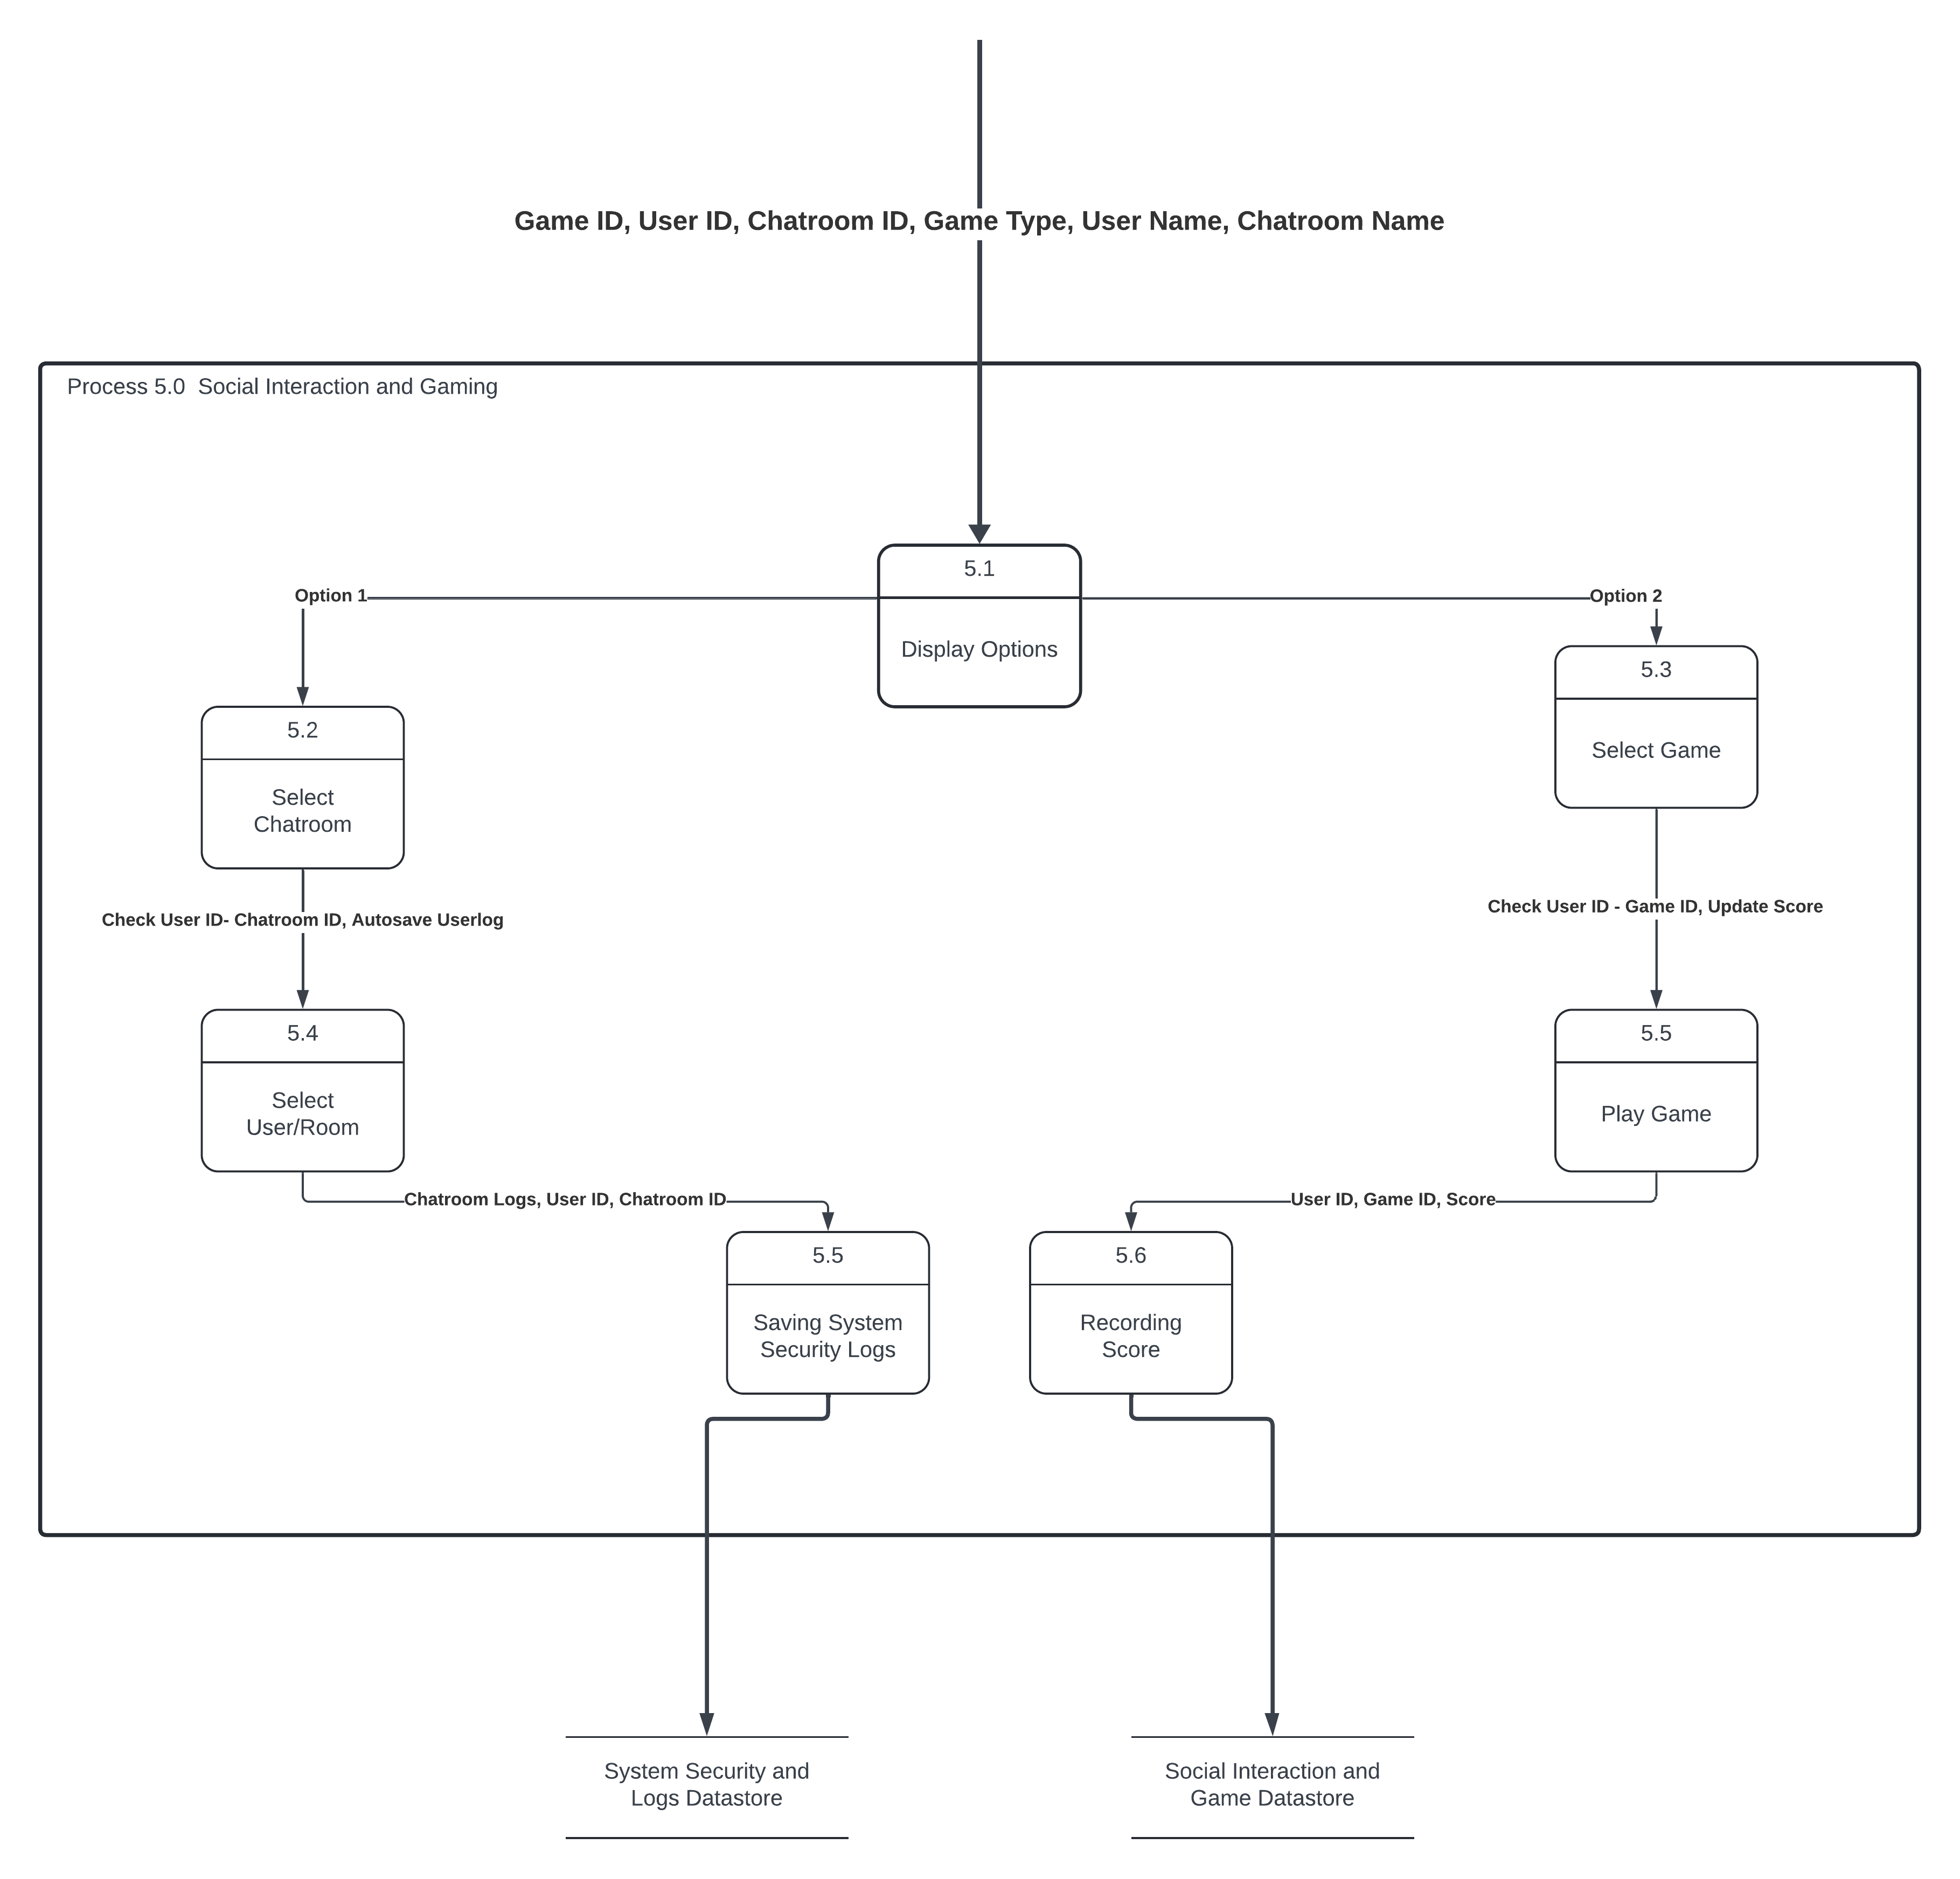Figure 11.2: Data Flow Level 1.1

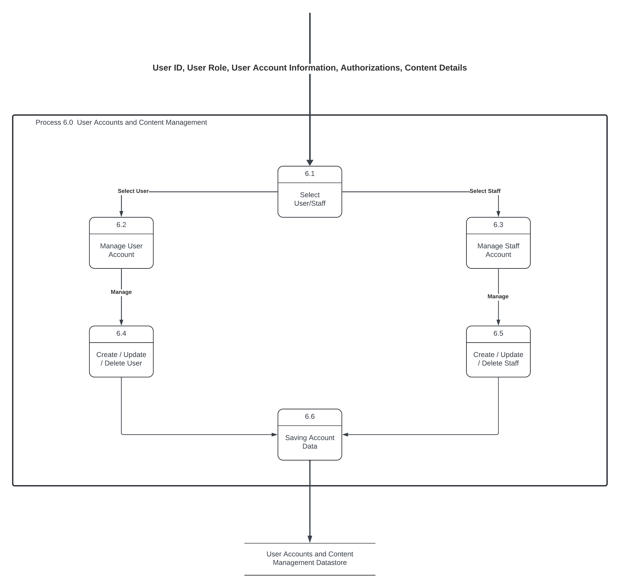Figure 11.3: Data Flow Level 1.2

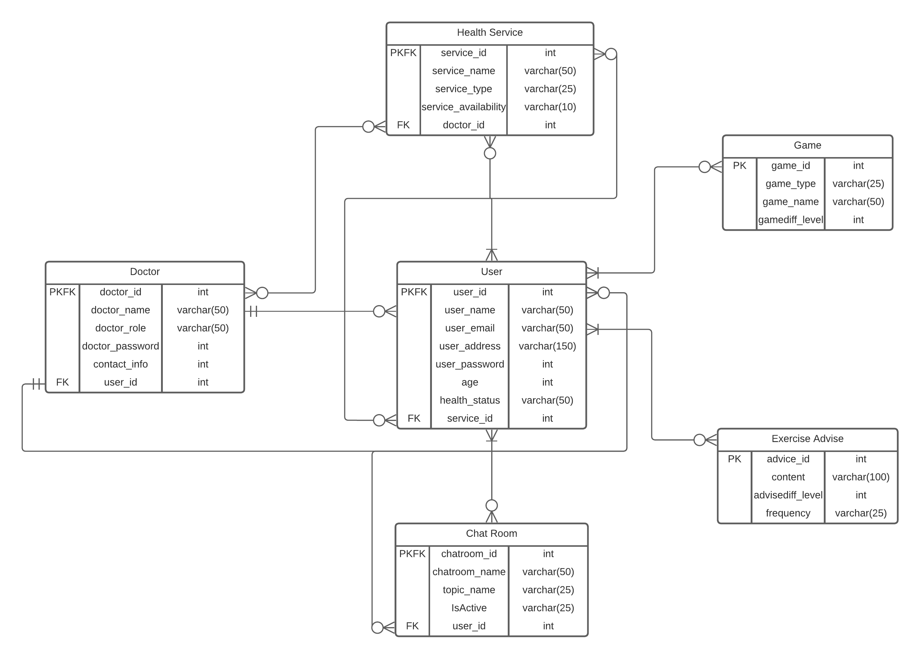Figure 11.4: DataBase Table

# Glossary

BPMN – Business Process Model and Notation

CSS – Cascading Style Sheets

DB- Database

GUI – Graphical User Interface

HTML – Hyper-Text Markup Language

IDE – Integrated Development Environment

OS – Operating System

SDS – Software Design Specification

SQL – Structured Query Language

SRS – Software Requirements Specification

UI – User Interface

UML – Unified Modeling Language

# Bibliography

LucidChart www.lucidchart.com

Figma https://www.figma.com/

Modelio https://www.modeliosoft.com/